Therapeutic Mindfulness: A Healing Skill, Not A Coping Skill
October 8, 2024 5:00 PM-7:00 PM *Remote attendance option available*
StoryPoint Ft Wayne North, 3715 Union Chapel Road, Ft Wayne IN 46845

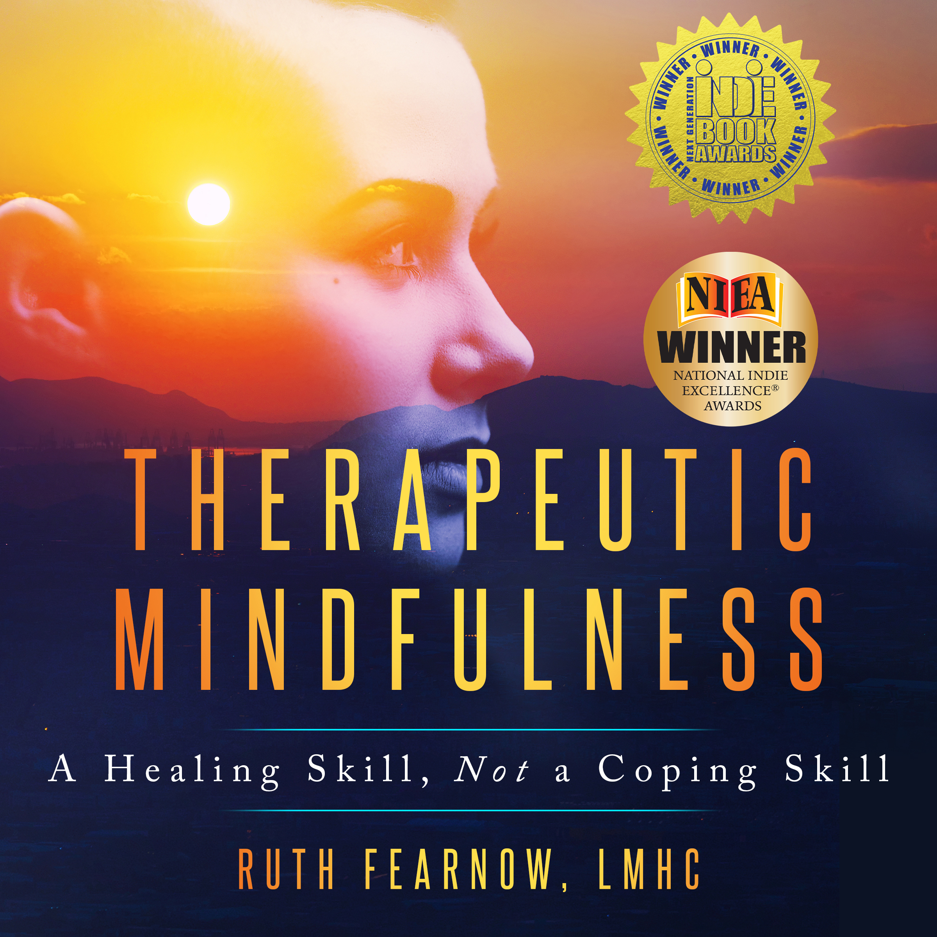  Winner of 2 awards:  2024 Next Generation Indie Book Awards for Self Help  2024 National Indie Excellence Awards for Mind/Body/Spirit  Ruth Fearnow is a therapist, author and speaker. Her first book, Therapeutic Mindfulness, is a synthesis of her decades-long meditation practice and her work healing trauma and mental distress |  | Objectives:  - Describe the difference between mindfulness and therapeutic mindfulness.  - List the default strategies of the emotional mind.  - Describe changes observed in one person when going through the process of therapeutic mindfulness.  Register @ CMSAFW.com  Tickets for CMSA & NASW members $15; Non-members $25; Students $10  CCM PACE approved for 1 CE  NASW IN has been approved 1 CEH  