Agenda and Bio

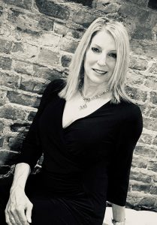
Since 2000, Linda Saunders has been a sought after speaker throughout the United States at national and regionally based industry conventions and trade association conferences She is a frequent guest lecturer at The Ohio State University and at all major hospital and health care systems throughout the Midwest. Linda is a requested speaker for nationally approved continuing education programs that unite professionals across the health care continuum and create collaborative and energy-infused backdrops for learning and strengthening relationships.

5:45 – 6:00 PM ET, can start logging into Zoom, greeting, thank our sponsor Vancrest Health Care Centers
6:00 – 7:00 PM, presentation
7:00 – 7:10 PM, questions
Program Objectives:
1. Participants will distinguish between IQ, EQ, SQ and AQ - Adversity Intelligence
2. Participants will identify the reasons why AQ plays an important role within their lives, both personally and professionally.
3. Participants will integrate and apply any of the 20 ways/tips that will foster their success in overcoming challenges in their lives and fostering their ability to rebound and "stay the course".
4. Participants will prioritize the importance of work/life balance by applying proven ways to prevent burnout.
Evaluations and certificates of attendance will be emailed to you at the address you used for registration. Linda has obtained CCM, NASW and RN approval for 1.0 contact hour.

Sponsored by:
